Whole Family Wellbeing Programme- Angus  Transforming services, supporting families |  | May 2026 edition 3
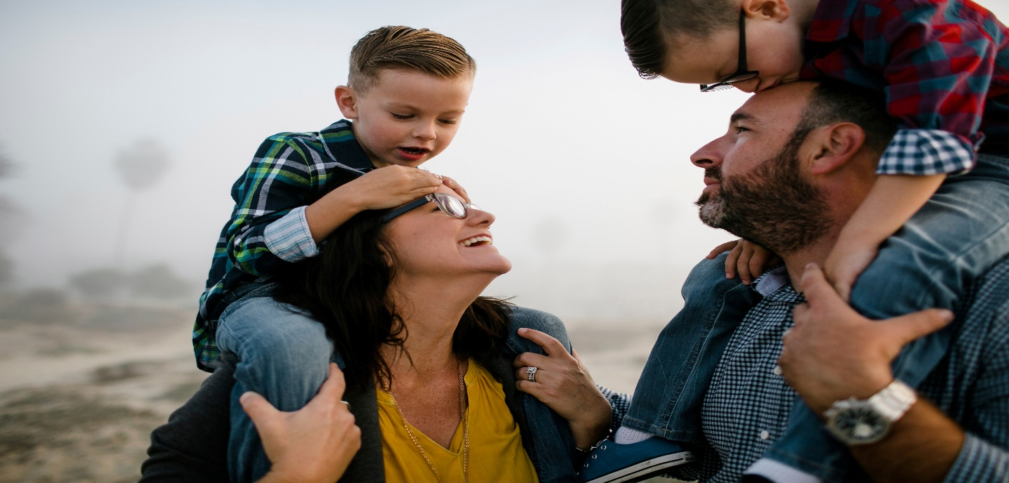
Transforming services, supporting families  By Lynne Robertson  Welcome!  The Whole Family Wellbeing Fund (WFWF) has been making an impact in Angus since April 2022, working to transform services for families who need them most. With funding for five years, the programme is built on a collaborative, early intervention approach designed to help families thrive, not just survive.  Focusing on six key family types, our work aims to ensure families receive the right support at the right time, reducing crisis escalation and promoting long-term wellbeing. This aligns with key national priorities, including The Promise, the UNCRC, Scotland’s Child Poverty Plan, and research on holistic family support.  With so much happening, we wanted to share an update about some of our funded projects and what’s coming next!  A Small Paddle, a Big Welcome: Pickleball Supporting New Scots in Angus  Ross Taylor, Angus Alive, has been in touch to tell us about their exciting new project:  “Since project launch, we have been working in partnership with the Angus Council resettlement team, Active Schools and Pickleball Scotland to design an opportunity that enabled New Scots families an opportunity to further increase their experiences living in Angus through being physically active together. Through the platform of Pickleball, we have activated a two-layer approach.  In phase one, we are engaging with new Scots aged 16-26, who are known to the resettlement team, Active Schools or DA college. Over 6 weeks, we have welcomed 7 new Scots into a weekly pickleball session in Arbroath, where they are learning not only how to play the game, but also how to facilitate pickleball activity with their own families. This is critical, as in phase two of the project, we will activate the young new Scots to deliver weekly whole family pickleball activity in Arbroath, all at zero cost to participants and families.  We are chuffed so far because we have gone from a taster session in the college - where 90% of the young people didn't know what pickleball was - to now being close to deploying them as volunteers, with a view to more families trying the activity within the new Scots Community. We are seeing confidence, social connections and relationships with physical activity all growing across phase one, which we hope continues the further we go in our project”  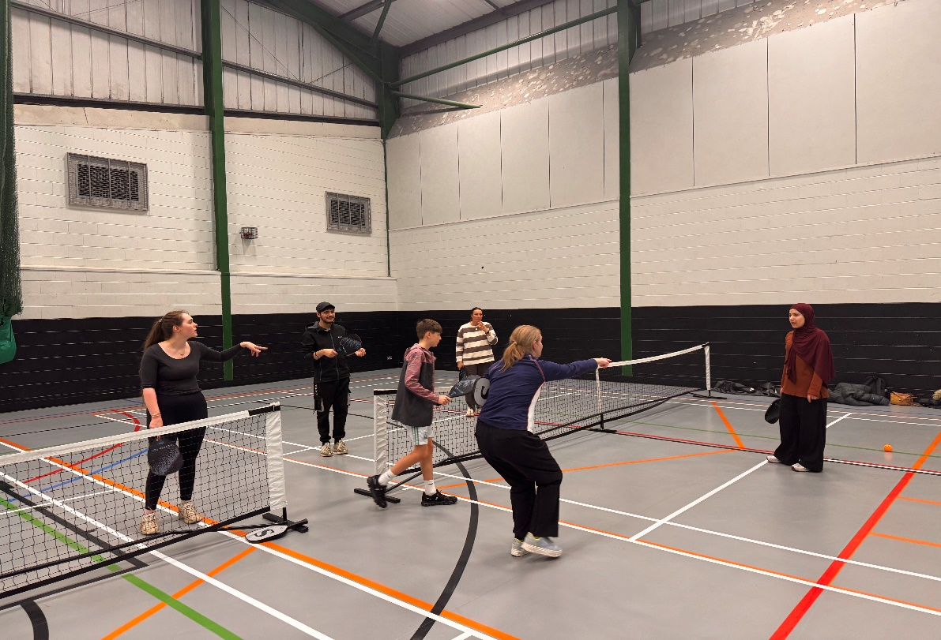  Pickleball: Opening Doors for New Scots Families  In the last newsletter we highlighted the work of the new Home-Start Angus Whole Family Wellbeing Support Service that supports pregnant women and their families, by matching families with appropriate local services, ensuring early intervention and support to improve maternal and child health outcomes.  We are pleased to report that service is “up and running” with families being supported at the earliest opportunity as well as the launch of the new Positive Pathways group which is a “moving on” group for parents whose wee ones have started nursery and for those parents who need that wee bit extra support.  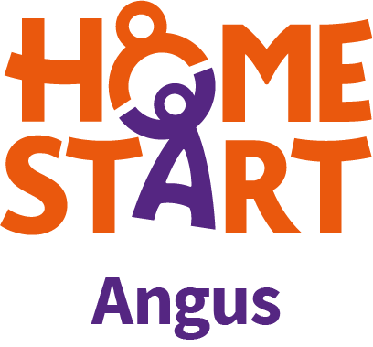    Supporting Whole Family Wellbeing Through Mediation, Play Therapy and Team Support    As part of the Whole Family Wellbeing Framework, we at Relationships Scotland Tayside & Fife are able to offer support across providers. This can be not only as direct referrals for mediation for families in conflict or play therapy for children affected by conflict or trauma, we are also able to support your teams through informal discussions, offering support and resources to strengthen your team's own ability to deal with conflict and communication difficulties within the families you support, and to triage and refer to us  Info & Contacts: 01382 201 343  www.rstf.co.uk info@rstf.co.uk meredith.c@rstf.co.uk |  | What’s New
TAKE A LOOK INSIDE
What’s the update regarding WFW program Angus?
Funding
Check out the latest about grant funding

Putting Practice into Words: We’d Love to Hear From You

WFWF grant funding  The next round of the Whole Family Wellbeing Fund grant funding in Angus is under design. It is anticipated that this year’s grant funding will support projects that closely align with the Integrated Childrens’ Services Plan 2026 - 2029.  Further details will be shared in due course.  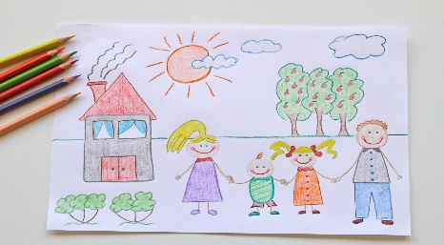  Putting Practice into Words: We’d love to hear from you!  We’d love this newsletter to reflect the breadth and impact of the work happening across our partners, projects and teams. If you have an update, reflection, success story or learning from your Whole Family Wellbeing work, please consider contributing a short article. Your experiences help us celebrate what’s working, share learning across the partnership, and strengthen connections between colleagues and services. Contributions can be as informal or as structured as you like – every story matters. |  |  | Building a Community of Practice for WFWF  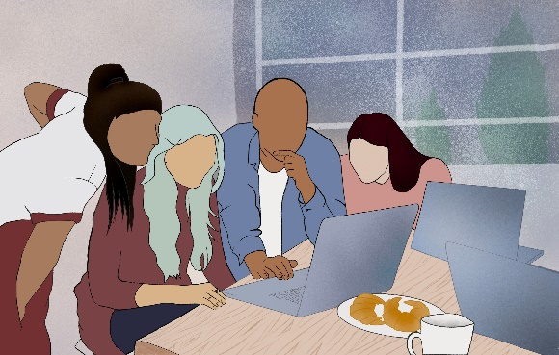  We have made a start to establishing a community of practice which will bring together practitioners, partners and organisations with a shared interest in early, preventative support for children, young people and families. The community of practice (for WFWF funded partners only) will provide a space to share good practice, exchange learning, explore new ways of working and reflect collectively on what helps families thrive.  If you are a WFWF funded project and are interested in being part of this community of practice, please contact Lynne Robertson WFWF Co-ordinator email: RobertsonL@angus.gov.uk
 | To stay up to date with all things related to the Whole Family Wellbeing Program in Angus - sign up to our dedicated portal which launched in April 2025. This will be the main hub for program information, featuring resource pages, regular news updates and key contacts. The portal can be found on the VAA website, please contact VAA for details.  By registering, you are ensuring you stay informed and connected. Thanks for being part of the journey.

