Whole Family Wellbeing Programme- Angus  Transforming services, supporting families |  | January 2026 edition 2
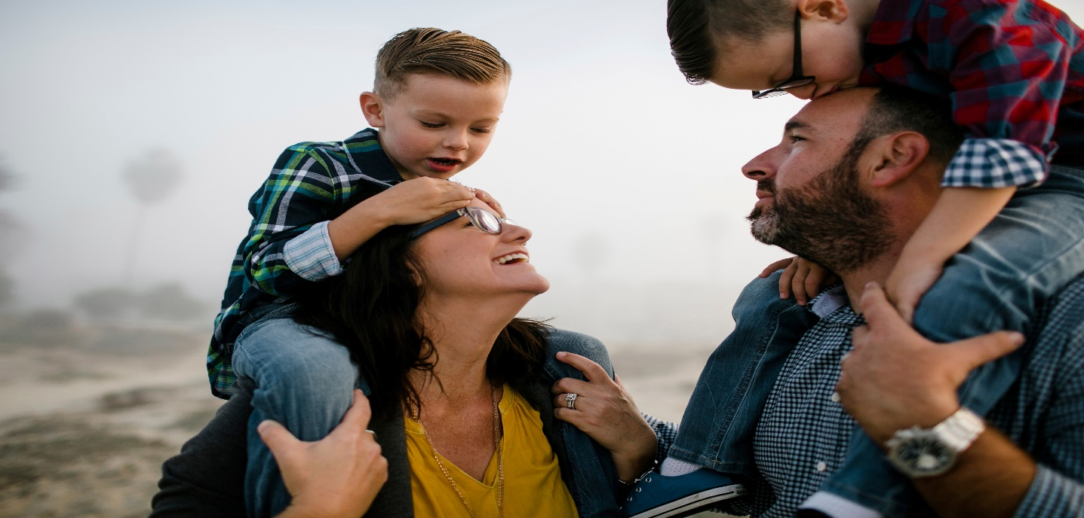
Transforming services, supporting families  By Lynne Robertson  Welcome!  The Whole Family Wellbeing Fund (WFWF) has been making an impact in Angus since April 2022, working to transform services for families who need them most. With funding for five years, the programme is built on a collaborative, early intervention approach designed to help families thrive, not just survive.  Focusing on six key family types, our work aims to ensure families receive the right support at the right time, reducing crisis escalation and promoting long-term wellbeing. This aligns with key national priorities, including The Promise, the UNCRC, Scotland’s Child Poverty Plan, and research on holistic family support.  With so much happening, we wanted to share an update on our journey so far and what’s coming next!  Shaping the future of Children's Services in Angus  Did you know the current Angus Integrated Children Services Plan runs until March 2026? Work is underway to inform the next plan for 2026 to 2029. Engagement activity will take place with children, young people, parents, carers, families and professionals to understand what is working well and where improvements are needed.  Partners and communities are encouraged to look out for surveys, questionnaires and opportunities to take part in focus groups over the coming weeks. Your views and experiences will play a vital role in shaping future services.  The new Home-Start Angus Whole Family Wellbeing Support Service will identify, engage, and assess the needs of families in Angus. It will act as a single point of contact to match families with appropriate local services, ensuring early intervention and support to improve maternal and child health outcomes.  The Support Service will focus on supporting pregnant women and their families, with the view of building capacity (through learning, monitoring and evaluation) and will also focus on developing services for families with children up to 3 years old.  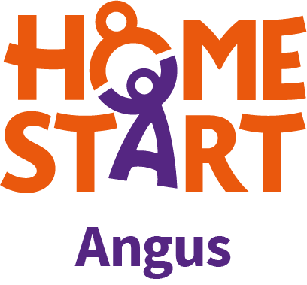  From Investment to Impact!  The WFWF digital data collection and performance framework is now live! Data from 16 WFWF funded projects will be gathered and analysed to demonstrate how the fund is supporting improved outcomes for children, young people and families across Angus. This information will be used to evidence impact, inform strategic planning and future funding decisions, and support learning and collaboration across partners delivering whole family, preventative support. |  | What’s New
TAKE A LOOK INSIDE
What’s the update regarding WFW program Angus?
Funding
Check out the latest about grant funding

WFWF grant funding  The first round of the Whole Family Wellbeing Fund grant funding in Angus has now concluded and we would like to thank all organisations that applied for both the small and large grant awards.  All applications were assessed through a robust evaluation process, and we are pleased to confirm that 5 organisations have been awarded small grant awards and a further 5 organisations have received large grant awards.  The funded projects will submit regular data and performance information enabling us to evidence the impact this investment is having on organisations, children and families across Angus. This learning will also help us inform priorities for future WFWF investment.  It is anticipated that the next tranche of WFWF grant funding will open in April/May 2026 - further details to follow in due course.   |  |  | Building a Community of Practice for WFWF    We are establishing a community of practice to bring together practitioners, partners and organisations with a shared interest in early, preventative support for children, young people and families. The community of practice will provide a space to share good practice, exchange learning, explore new ways of working and reflect collectively on what helps families thrive. By coming together across services and sectors, the group will support collaboration, learning and continuous improvement in practice.  If you're interested in being part of this community of practice, please contact Lynne Robertson WFWF Co-ordinator email: RobertsonL@angus.gov.uk
 | To stay up to date with all things related to the Whole Family Wellbeing Program in Angus - sign up to our dedicated portal which launched in April 2025. This will be the main hub for program information, featuring resource pages, regular news updates and key contacts. The portal can be found on the VAA website, please contact VAA for details.  By registering, you are ensuring you stay informed and connected. Thanks for being part of the journey.

