Digital Boost - Fully Funded

Microsoft 365 Training for

Angus Third Sector Organisations
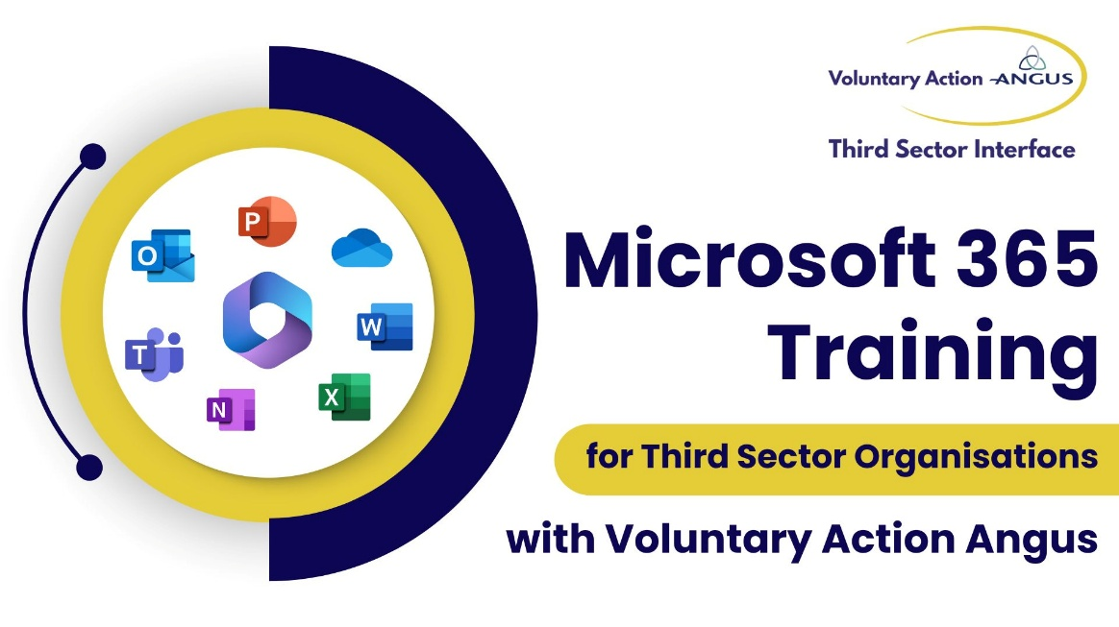
We are delighted to share links below to new, fully funded Microsoft 365 training we will be delivering this year, over February and March.
There are two date options for each of the three sessions. Ideally, to get the full benefit of the training and ensure you don't miss any key features, we highly recommend attending all three sessions as each one builds on the last.

Introduction to Microsoft 365

- Mon 2nd Feb, 2pm - 4pm
- Wed 4th March, 6pm -8pm

Register here: https://bit.ly/49PWkLj

Collaboration with OneDrive, SharePoint and Teams

- Tues 3rd Feb: 10am-12pm
- Wed 11th March: 6pm-8pm

Register here: https://bit.ly/3LqwQuQ

Task Management in Microsoft 365

- Thurs 5th Feb: 10am-12pm
- Wed 25th March: 6pm-8pm

Register here: https://bit.ly/4jDyBBw

